Group Discussion Room Booking System at Central Library

1. **ROOM OOKING STATUS**

**(Click at Room Booking at Home Page of Central Library Website http://cl.thapar.edu)**

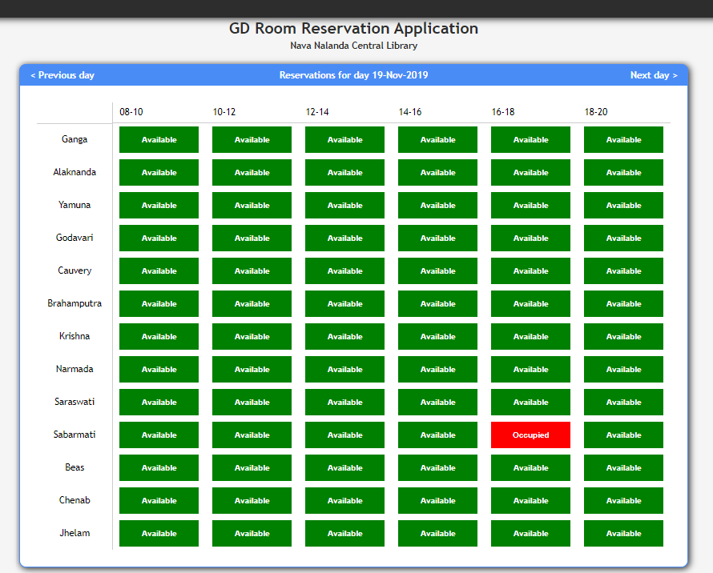

Step 2: Register or Login

If You are First Time User, Click at ‘New User’.

***Note: Use thapar.edu email ID Only.***

If Already Registered, use Your Credentials to Login

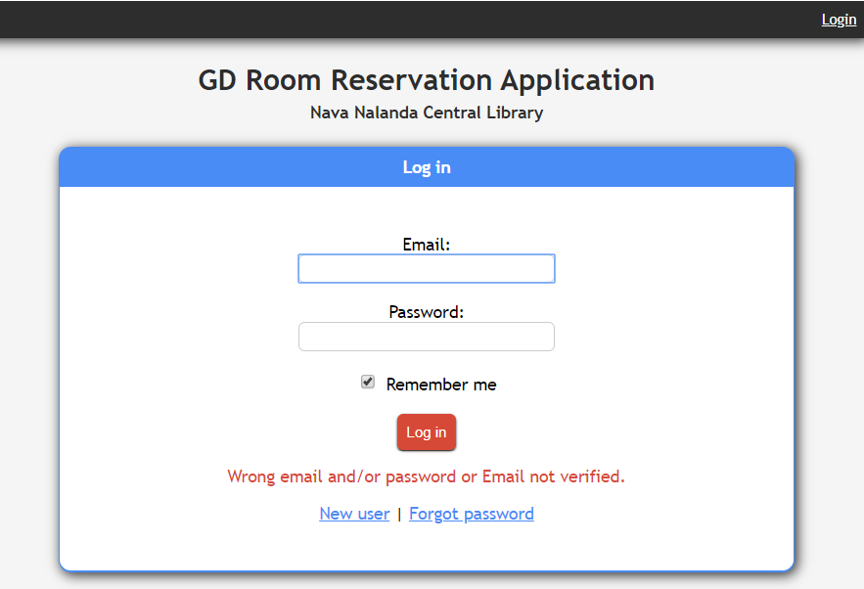

Step 3: Create a Group

You can create a group by typing a group name and clicking on the create group button.

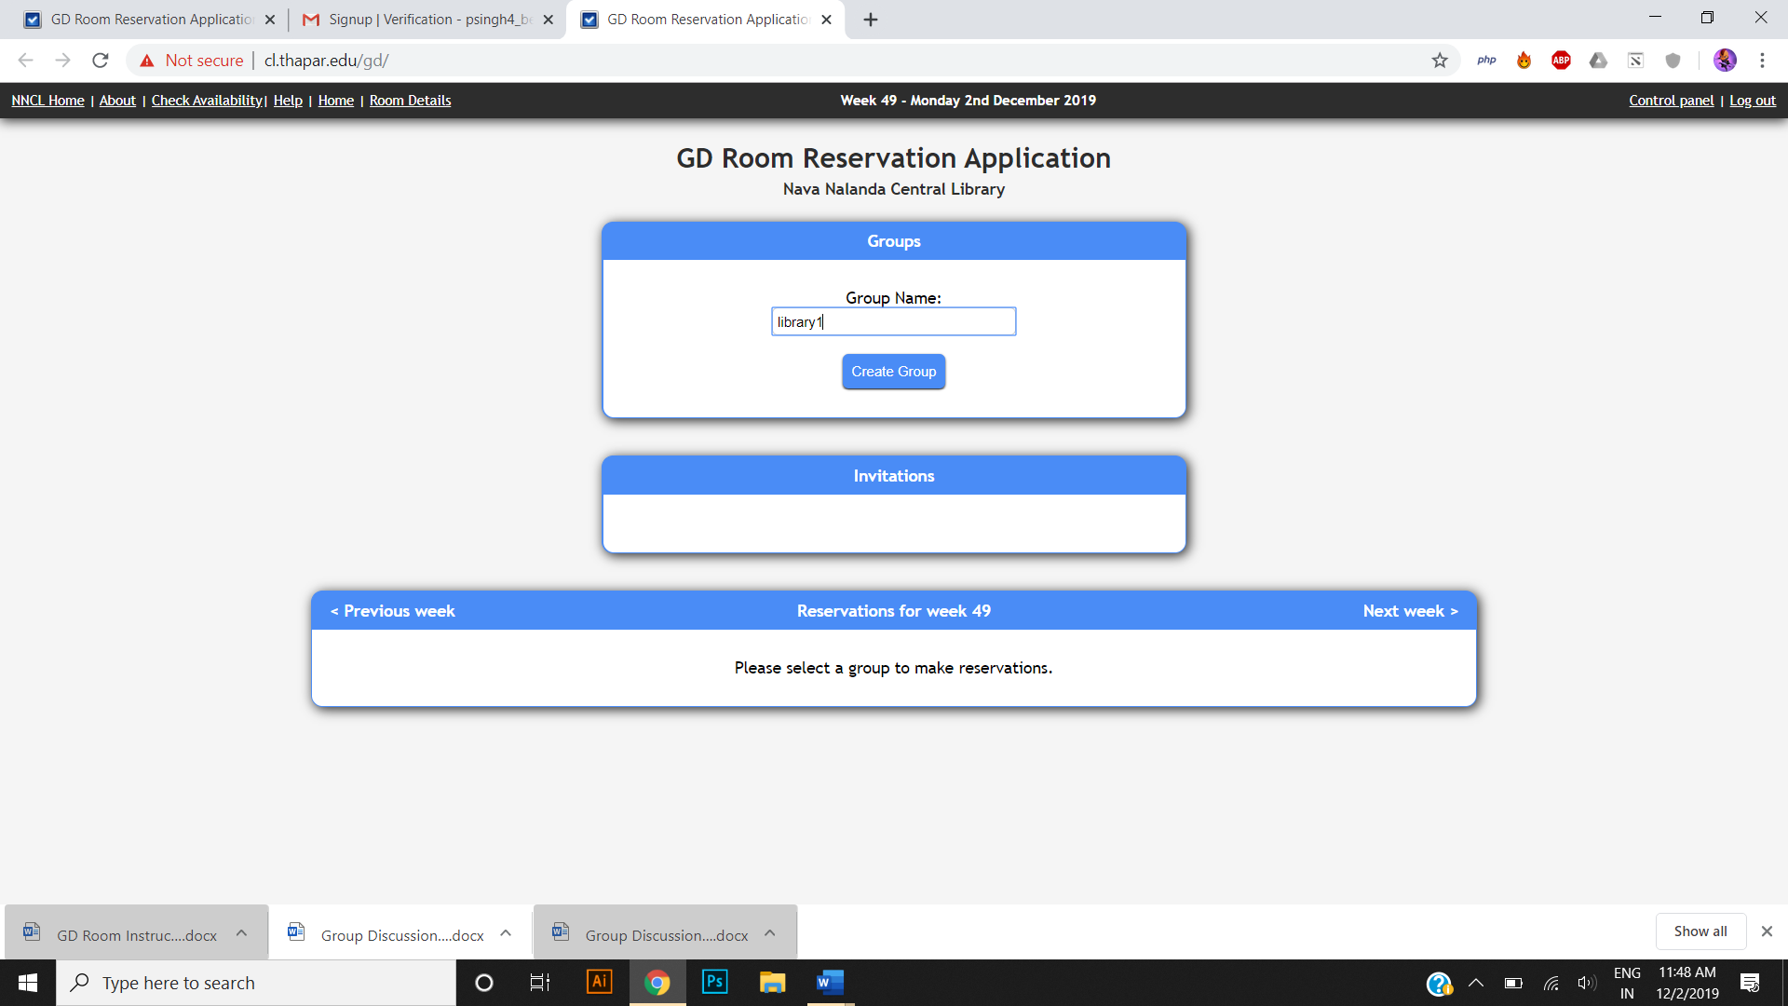

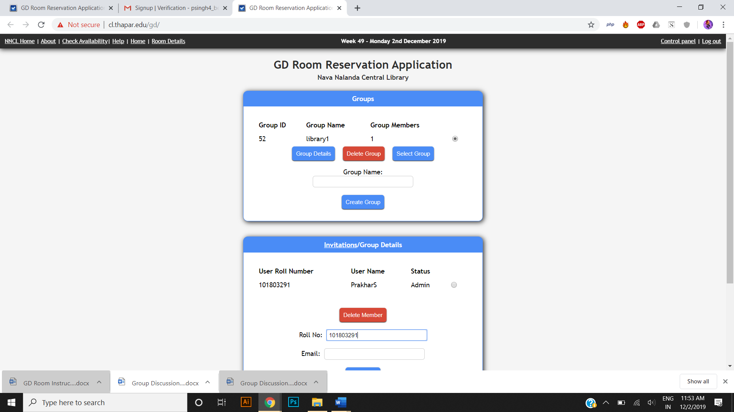

Step 4: Inviting members to your group

You can invite members to your group by clicking on the group details button and typing the mail address and roll number of the person you want to invite**.**

***Note: Please ensure that the person has registered beforehand on the GD room booking website*.**

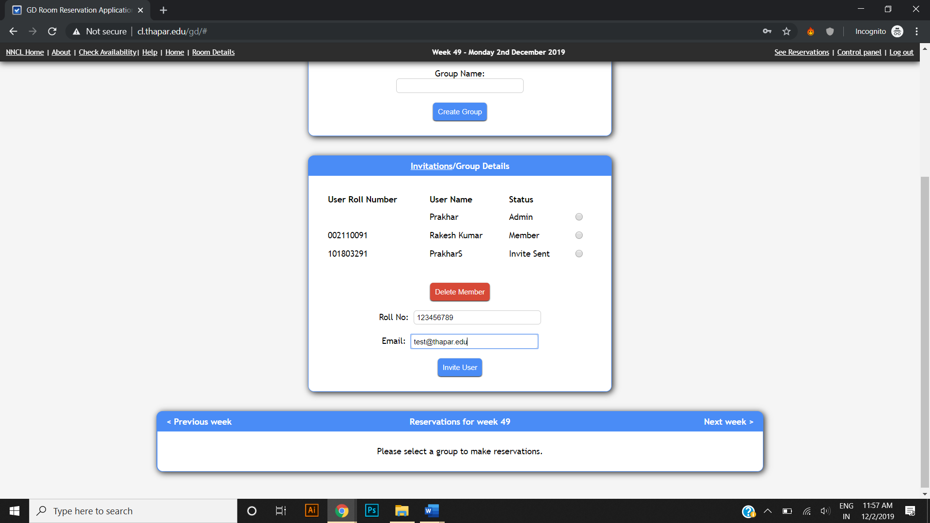

Step 5: Accepting Invites

You can accept invites for a group by logging in and clicking on the accept invite button as shown below.

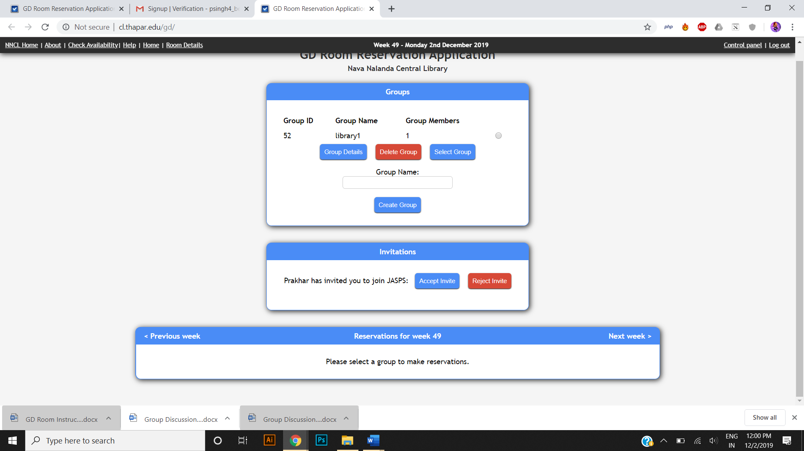

Step 6: Booking the Room

You can book the GD room by selecting the group and time from the chart.

***Note: Please make sure you have at least 4 members in your group before proceeding to make any bookings.***

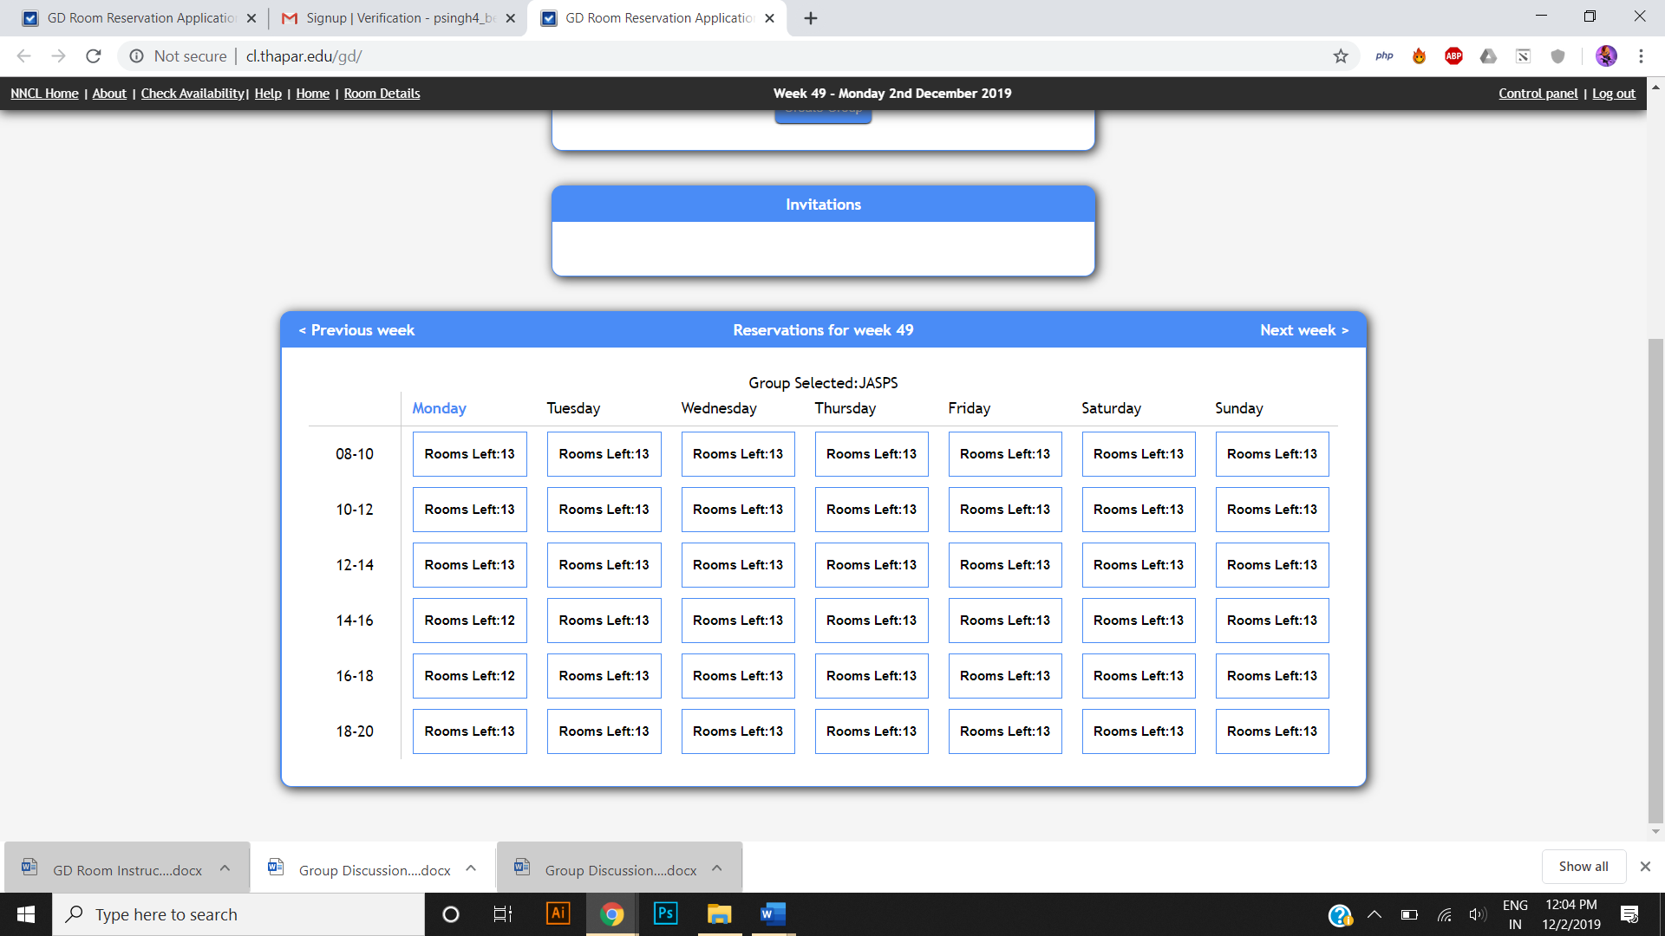

Select a slot and click on the desired room.

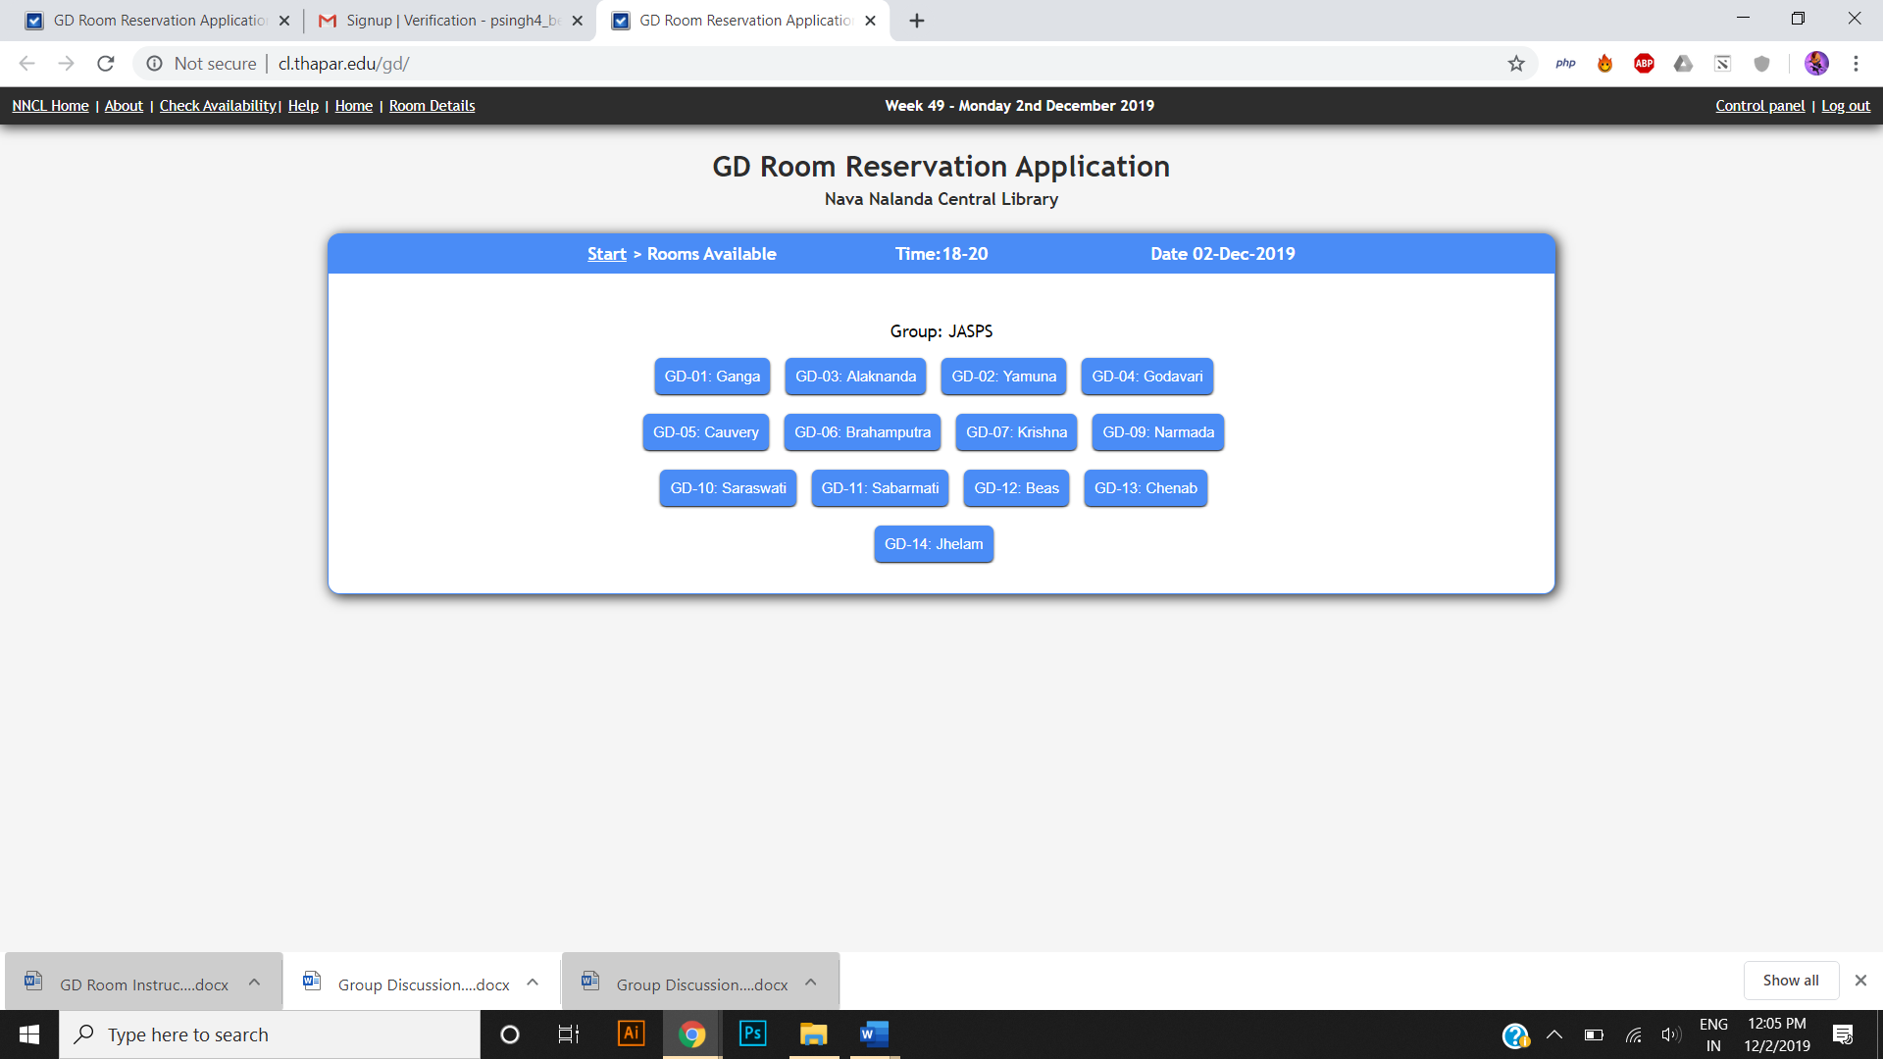

Step 7: Booking Confirmed

Once you click on a room and confirm the slot will be booked by your group for the GD room and you’ll get a confirmation like the one shown below.

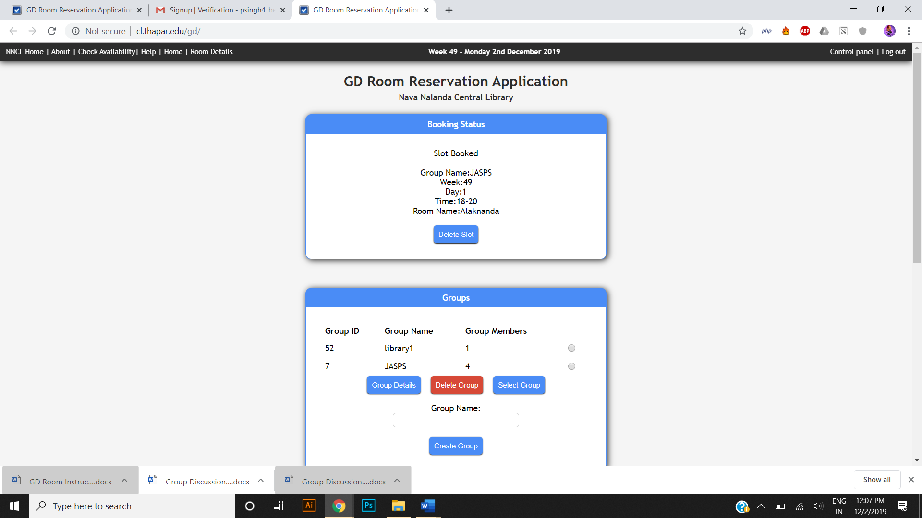

***NOTE: You can make a maximum of two bookings at a time.***